**POLYDEMENTOR**

Made by:

Nilay Jaiswal

Sayantan Paul

Arvind Singhal

Nishit Sharma

Sahil Kumar

**Polymer degradation** is a change in the properties—[tensile strength](http://en.wikipedia.org/wiki/Tensile_strength), [color](http://en.wikipedia.org/wiki/Color), shape, etc.—of a [polymer](http://en.wikipedia.org/wiki/Polymer) or polymer-based product under the influence of one or more environmental factors such as [heat](http://en.wikipedia.org/wiki/Heat), [light](http://en.wikipedia.org/wiki/Light) or [chemicals](http://en.wikipedia.org/wiki/Chemical) such as acids, alkalis and some [salts](http://en.wikipedia.org/wiki/Salts). These changes are usually undesirable, such as cracking and chemical disintegration of products or, more rarely, desirable, as in [biodegradation](http://en.wikipedia.org/wiki/Biodegradation), or deliberately lowering the [molecular weight](http://en.wikipedia.org/wiki/Molecular_weight) of a polymer for recycling. The changes in properties are often termed "aging".

**Biodegradation of polymers**

In a finished product such a change is to be prevented or delayed. Degradation can be useful for [recycling](http://en.wikipedia.org/wiki/Recycling)/reusing the polymer waste to prevent or reduce environmental [pollution](http://en.wikipedia.org/wiki/Pollution). Degradation can also be induced deliberately to assist structure.

Polymeric [molecules](http://en.wikipedia.org/wiki/Molecule) are very large (on the molecular scale), and their unique and useful properties are mainly a result of their size. Any loss in chain length lowers tensile strength and is a primary cause of premature cracking.

**COMMODITY POLYMERS**

Today there are primarily seven commodity polymers in use: [polyethylene](http://en.wikipedia.org/wiki/Polyethylene), [polypropylene](http://en.wikipedia.org/wiki/Polypropylene), [polyvinyl chloride](http://en.wikipedia.org/wiki/Polyvinyl_chloride), [polystyrene](http://en.wikipedia.org/wiki/Polystyrene), [polycarbonate](http://en.wikipedia.org/wiki/Polycarbonate), and [poly(methylmethacrylate)](http://en.wikipedia.org/wiki/Poly(methyl_methacrylate)) ([Plexiglas](http://en.wikipedia.org/wiki/Plexiglas)). These make up nearly 98% of all polymers and plastics encountered in daily life. Each of these polymers has its own characteristic modes of degradation and resistances to heat, light and chemicals. Polyethylene, polypropylene, and poly (methyl methacrylate) are sensitive to [oxidation](http://en.wikipedia.org/wiki/Oxidation) and [UV radiation](http://en.wikipedia.org/wiki/UV_radiation), while PVC may discolor at high temperatures due to loss of [hydrogen chloride](http://en.wikipedia.org/wiki/Hydrogen_chloride) gas, and become very brittle. PET is sensitive to [hydrolysis](http://en.wikipedia.org/wiki/Hydrolysis) and attack by strong [acids](http://en.wikipedia.org/wiki/Acid), while polycarbonate depolymerizes rapidly when exposed to strong [alkalis](http://en.wikipedia.org/wiki/Alkali).

For example, polyethylene usually degrades by random scission—that is by a random breakage of the linkages (bonds) that hold the [atoms](http://en.wikipedia.org/wiki/Atoms) of the polymer together. When this polymer is heated above 450 [Celsius](http://en.wikipedia.org/wiki/Celsius) it becomes a complex mixture of molecules of various sizes that resemble gasoline. Other polymers—like polyalphamethylstyrene—undergo 'specific' chain scission with breakage occurring only at the ends; they literally unzip or depolymerize to become the constituent [monomers](http://en.wikipedia.org/wiki/Monomers).

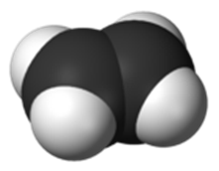

**Polyethylene**

Polyethylene or polythene ([IUPAC](http://en.wikipedia.org/wiki/IUPAC) name polyethene or poly(methy-lene)) is the most common [plastic](http://en.wikipedia.org/wiki/Plastic). The annual production is approximately 80 million metric tons. Its primary use is in [packaging](http://en.wikipedia.org/wiki/Packaging) ([plastic bag](http://en.wikipedia.org/wiki/Plastic_bag), [plastic films](http://en.wikipedia.org/wiki/Plastic_film), [geomembranes](http://en.wikipedia.org/wiki/Geomembranes" \o "Geomembranes), containers including [bottles](http://en.wikipedia.org/wiki/Bottle), etc.). Many kinds of polyethylene are known, with most having the [chemical formula](http://en.wikipedia.org/wiki/Chemical_formula) (C2H4)nH2. Thus PE is usually a mixture of similar [organic compounds](http://en.wikipedia.org/wiki/Organic_compound) that differ in terms of the value of n.

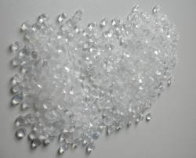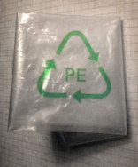

Polyethylene

p properties

Polyethylene Granules

PHYSICAL PROPERTIES

Polyethylene is a [thermoplastic](http://en.wikipedia.org/wiki/Thermoplastic) [polymer](http://en.wikipedia.org/wiki/Polymer) consisting of long hydrocarbon chains. Depending on the [crystallinity](http://en.wikipedia.org/wiki/Crystal_structure" \o "Crystal structure) and [molecular weight](http://en.wikipedia.org/wiki/Molecular_weight), a [melting point](http://en.wikipedia.org/wiki/Melting_point) and [glass transition](http://en.wikipedia.org/wiki/Glass_transition) may or may not be observable. The temperature at which these occur varies strongly with the type of polyethylene. For common commercial grades of medium- and high-density polyethylene the melting point is typically in the range 120 to 130 °C (248 to 266 °F). The melting point for average, commercial, low-density polyethylene is typically 105 to 115 °C (221 to 239 °F).

CHEMICAL PROPERTIES

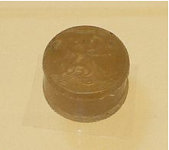Most LDPE, MDPE and HDPE grades have excellent chemical resistance, meaning that it is not attacked by strong acids or strong bases. It is also resistant to gentle oxidants and reducing agents. Polyethylene burns slowly with a blue flame having a yellow tip and gives off an odour of paraffin. The material continues burning on removal of the flame source and produces a drip. Crystalline samples do not dissolve at room temperature. Polyethylene (other than cross-linked polyethylene) usually can be dissolved at elevated temperatures in hydrocarbons such as [toluene](http://en.wikipedia.org/wiki/Toluene) or [xylene](http://en.wikipedia.org/wiki/Xylene), or in chlorinated solvents such as [trichloroethane](http://en.wikipedia.org/wiki/Trichloroethane) or [trichlorobenzene](http://en.wikipedia.org/wiki/Trichlorobenzene).

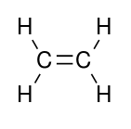

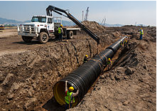

method to degrade polyethylene

**AIM:**

To degrade polyethylene using chemicals and bacteria.

**MATERIALS REQUIRED:**

1. LDPE (low density polyethylene) from garbage dump
2. Ethanol
3. Sodium Chloride (NaCl)
4. Pestle and Mortar
5. Incubator or Solar Cooker and Bulb as Alternative
6. Borosil Flasks
7. Analytical Precision Balance
8. Pseudomonas flourescens (bacteria) (optional)
9. Nutrient Broth (optional)
10. Soil sample from the same garbage dump

**THEORY:**

One of the main problems of polyethylene is that without special treatment it is not readily biodegradable, and thus accumulates. In Japan getting rid of plastics in an environmentally friendly way was the major problem discussed until the [Fukushima disaster](http://en.wikipedia.org/wiki/Fukushima_Daiichi_nuclear_disaster) in 2011. It was listed as a $90 billion market for solutions. Since 2008 Japan has rapidly increased the recycling of plastics, but still has a large rate of plastic wrapping which goes to waste.so here are a few steps with which we can degrade the polyethylene even in our backyard.

**PROCEDURE:**

1. Take a LDPE from a garbage dump.



1. Cut it into small pieces using a scissor.

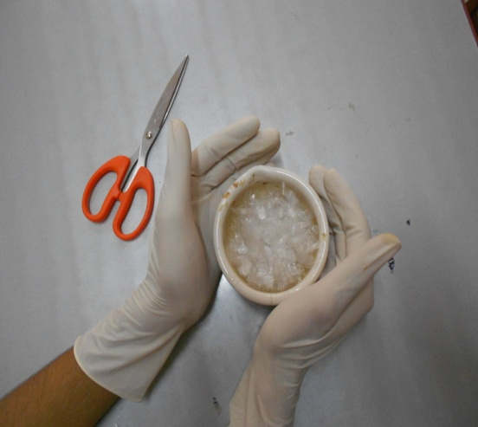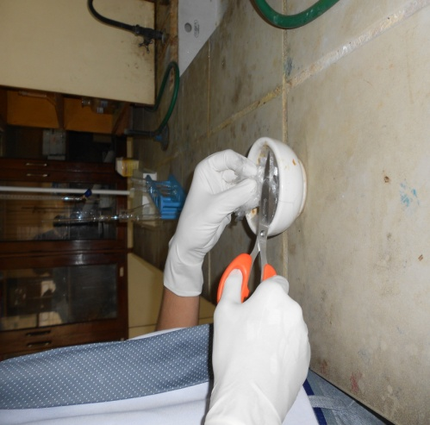

1. When done wash those pieces in ethanol and let them dry.
2. Now take some NaCl in a pestle and mortar and start crushing the LDPE until you get the fine fibers of LDPE.

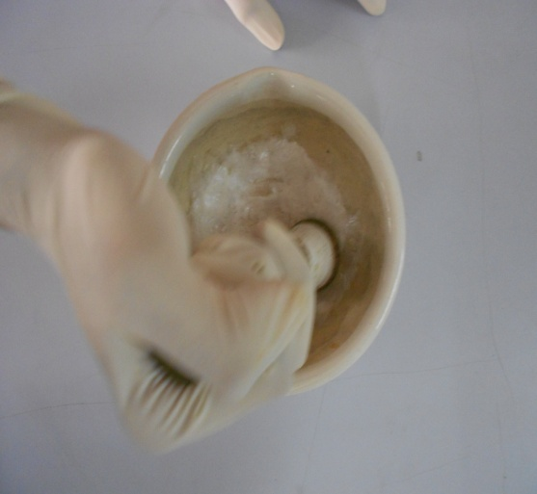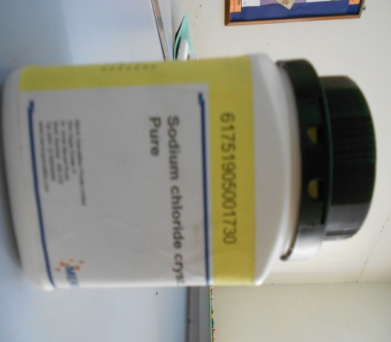

1. Now wash those fibres in water and let them dry.
2. Take some of the fibres and measure 100Mg of fibres using an analytical measuring balance.
3. Now take the fibers in a Borosil container/flask and mix some soil along with the water.
4. Keep that container/flask in an incubator or take a solar cooker and place the container/flask inside it for 3 to 4 weeks.
5. 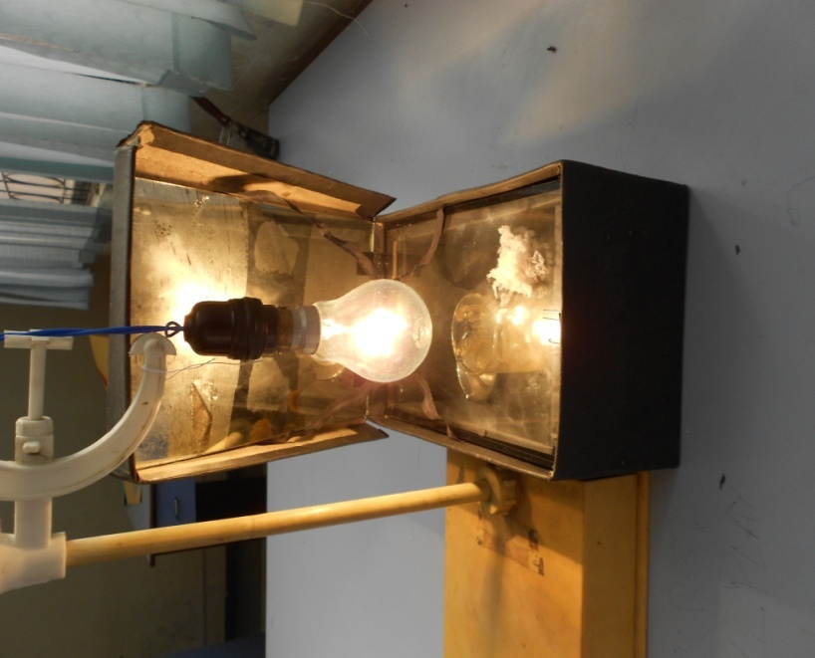Make sure that you are maintaining 50-60°C temperature for 3 to 4 weeks.

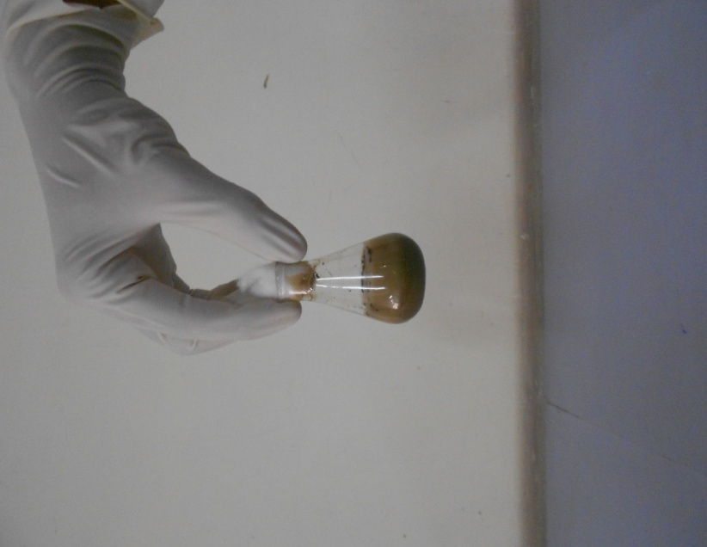**Observation:**

Strains of various bacterias like Pseudomonas, Streptomyces consists of enzymes which activate at a constant temperature of 50-60°C and break the C=C bond of Polyethylene.

In this process CO2 is released as by-product. This by-product is further utilized by :

1. Pseudomonas uses this CO2 for its own replication.

2. CO2 breaks Into CH4 as a fuel with the help of nanoparticle of Copper and Gold.

**RESULT:**

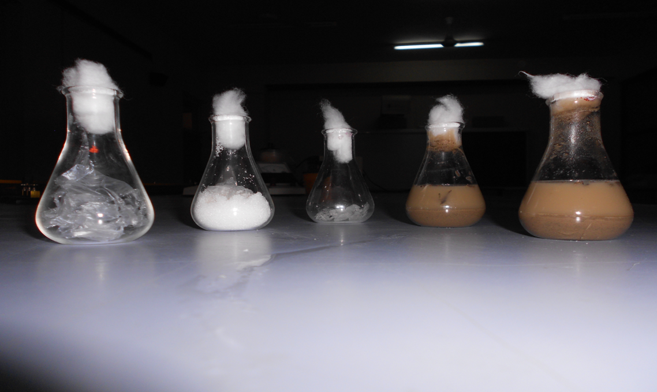You will see a gradual decrease in the weight of the Polyethylene.

|  |  |  |  |
| --- | --- | --- | --- |
| **Weight of PE*(g)**  **Initial Final** | | **Weight of PE degraded (g)** | **Percentage of PE degradation** |
| **0** | **0** | **0** | **0** |
| **0.1** | **0.085** | **0.015** | **15** |

**GRAPH**

TRENDS OF POLYETHYLENE DEGRADATION IN DIFFERENT TREATMENTS

**How does it work??**

During the whole process of degradation CO2 gas is evolved. We used a solar cooker due to absence of an incubator in our chemistry lab. We maintained the temperature of 54°C using a 100W bulb. To see how much CO2 gas is being evolved we kept NaOH solution in small bowl inside the solar cooker which turned into white coloured solid flakes within 3 days proving that degradation of LDPE releases a lot of CO2 gas.

But this CO2 gas also helps in activation of the soil enzymes! The bacteria *Pseudomonas flourescens* present in the soil starts multiplying and thus the degradation of polyethylene starts. Though being a slow process it is quite a great thing that we are now able to degrade the polyethene. It was thought that polythene is not at all degradable and slowly it would ruin our earth.

The excess of CO2 can harm the environment so by the use of copper and gold nanoparticles it can be converted into an efficient fuel.

Those two options, chemically speaking, consist of leaving CO2 unconverted for storage or adding oxygen to produce carbonate. A trickier chemical pathway consists of removing oxygen from the carbon, adding hydrogen instead -- which produces methane (CH4). The methane can be used for fuel, creating a sustainable loop of fuel to CO2 to fuel.

You know there is no such thing as a perpetual motion machine, so you can imagine that the conversion to methane requires energy. A catalyst can reduce the energy requirements -- in this case copper is known to catalyze conversion of carbon dioxide to methane with relatively little energy input. This would already have been embraced as a great solution if it were not for one problem: the copper quickly forms an oxide coating, like the patina which turns red copper roofs a beautiful (and stable) silver-green color.

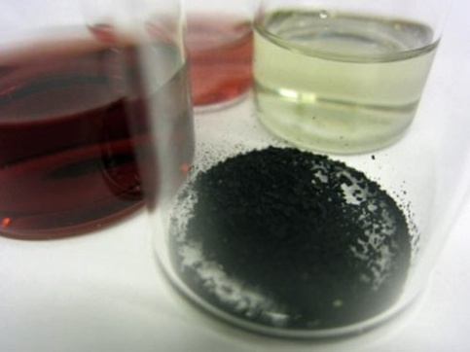

WHAT ARE ENZYMES?

**Enzymes** are large biological [molecules](https://en.wikipedia.org/wiki/Molecule) responsible for the thousands of [chemical interconversions](https://en.wikipedia.org/wiki/Metabolism) that sustain life. They are highly selective [catalysts](https://en.wikipedia.org/wiki/Catalysis), greatly accelerating both the rate and specificity of metabolic reactions, from the digestion of food to the synthesis of [DNA](https://en.wikipedia.org/wiki/DNA). Most enzymes are [proteins](https://en.wikipedia.org/wiki/Proteins), although some [catalytic RNA molecules](https://en.wikipedia.org/wiki/Ribozyme) have been identified. Enzymes adopt a specific [three-dimensional structure](https://en.wikipedia.org/wiki/Protein_structure), and may employ organic (e.g. [biotin](https://en.wikipedia.org/wiki/Biotin)) and inorganic (e.g. [magnesium](https://en.wikipedia.org/wiki/Magnesium) [ion](https://en.wikipedia.org/wiki/Ion)) [cofactors](https://en.wikipedia.org/wiki/Cofactor_(biochemistry)) to assist in catalysis.

In enzymatic reactions, the molecules at the beginning of the process, called [substrates](https://en.wikipedia.org/wiki/Substrate_(biochemistry)), are converted into different molecules, called [products](https://en.wikipedia.org/wiki/Product_(biology)). Almost all chemical reactions in a [biological cell](https://en.wikipedia.org/wiki/Cell_(biology)) need enzymes in order to occur at rates sufficient for life. Since enzymes are selective for their substrates and speed up only a few reactions from among many possibilities, the set of enzymes made in a cell determines which [metabolic pathways](https://en.wikipedia.org/wiki/Metabolic_pathway) occur in that cell.

Like all catalysts, enzymes work by lowering the [activation energy](https://en.wikipedia.org/wiki/Activation_energy) (*E*a‡) for a reaction, thus dramatically increasing the [rate of the reaction](https://en.wikipedia.org/wiki/Reaction_rate). As a result, products are formed faster and reactions reach their equilibrium state more rapidly. Most enzyme reaction rates are millions of times faster than those of comparable un-catalyzed reactions. As with all catalysts, enzymes are not consumed by the reactions they catalyze, nor do they alter the [equilibrium](https://en.wikipedia.org/wiki/Chemical_equilibrium) of these reactions. However, enzymes do differ from most other catalysts in that they are highly specific for their substrates. Enzymes are known to catalyze about 4,000 biochemical reactions. A few [RNA](https://en.wikipedia.org/wiki/RNA) molecules called [ribozymes](https://en.wikipedia.org/wiki/Ribozyme) also catalyze reactions, with an important example being some parts of the [ribosome](https://en.wikipedia.org/wiki/Ribosome). Synthetic molecules called [artificial enzymes](https://en.wikipedia.org/wiki/Artificial_enzyme) also display enzyme-like catalysis.

Enzyme activity can be affected by other molecules. [Inhibitors](https://en.wikipedia.org/wiki/Enzyme_inhibitor) are molecules that decrease enzyme activity; [activators](https://en.wikipedia.org/wiki/Enzyme_activator) are molecules that increase activity. Many [drugs](https://en.wikipedia.org/wiki/Drug) and[poisons](https://en.wikipedia.org/wiki/Poison) are enzyme inhibitors. Activity is also affected by [temperature](https://en.wikipedia.org/wiki/Temperature), [pressure](https://en.wikipedia.org/wiki/Pressure), chemical environment (e.g., [pH](https://en.wikipedia.org/wiki/PH)), and the [concentration](https://en.wikipedia.org/wiki/Concentration) of substrate. Some enzymes are used commercially, for example, in the synthesis of [antibiotics](https://en.wikipedia.org/wiki/Antibiotic). In addition, some household products use enzymes to speed up biochemical reactions (e.g., enzymes in biological[washing powders](https://en.wikipedia.org/wiki/Washing_powder) break down protein or [fat](https://en.wikipedia.org/wiki/Fat) stains on clothes; enzymes in [meat tenderizers](https://en.wikipedia.org/wiki/Papain) break down proteins into smaller molecules, making the meat easier to chew).

Enzymes serve a wide variety of [functions](https://en.wikipedia.org/wiki/Function_(biology)) inside living organisms. They are indispensable for [signal transduction](https://en.wikipedia.org/wiki/Signal_transduction) and cell regulation, often via [kinases](https://en.wikipedia.org/wiki/Kinase) and [phosphatases](https://en.wikipedia.org/wiki/Phosphatase). They also generate movement, with [myosin](https://en.wikipedia.org/wiki/Myosin) hydrolyzing ATP to generate [muscle contraction](https://en.wikipedia.org/wiki/Muscle_contraction) and also moving cargo around the cell as part of the [cytoskeleton](https://en.wikipedia.org/wiki/Cytoskeleton). Other ATPases in the cell membrane are [ion pumps](https://en.wikipedia.org/wiki/Ion_pump_(biology)) involved in [active transport](https://en.wikipedia.org/wiki/Active_transport). Enzymes are also involved in more exotic functions, such as [luciferase](https://en.wikipedia.org/wiki/Luciferase) generating light in [fireflies](https://en.wikipedia.org/wiki/Firefly)

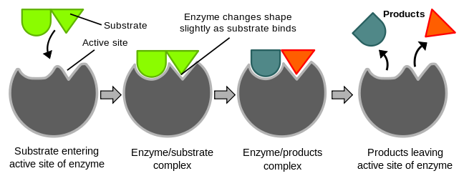

WHAT ARE NANOPARTICLES?

In [nanotechnology](https://en.wikipedia.org/wiki/Nanotechnology), a particle is defined as a small object that behaves as a whole unit with respect to its transport and properties. [Particles](https://en.wikipedia.org/wiki/Particles) are further classified according to diameter. Coarse particles cover a range between 10,000 and 2,500 [nanometers](https://en.wikipedia.org/wiki/Nanometers). Fine particles are sized between 2,500 and 100 nanometers. Ultrafine particles, or nanoparticles are sized between 1 and 100 nanometers. The reason for this double name of the same object is that, during the 1970-80's, when the first thorough fundamental studies with "nanoparticles" were underway in the USA (by [Granqvist](https://en.wikipedia.org/wiki/Claes-G%C3%B6ran_Granqvist" \o "Claes-Göran Granqvist) and Buhrman) and Japan, (within an ERATO Project) they were called "ultrafine particles" (UFP). However, during the 1990s before the [National Nanotechnology Initiative](https://en.wikipedia.org/wiki/National_Nanotechnology_Initiative) was launched in the USA, the new name, "nanoparticle" had become fashionable (see, for example the same senior author's paper 20 years later addressing the same issue, lognormal distribution of sizes ). Nanoparticles may or may not exhibit size-related properties that differ significantly from those observed in fine particles or bulk materials. Although the size of most [molecules](https://en.wikipedia.org/wiki/Molecule) would fit into the above outline, individual molecules are usually not referred to as nanoparticles.

[Nanoclusters](https://en.wikipedia.org/wiki/Cluster_(physics)) have at least one dimension between 1 and 10 nanometers and a narrow size distribution. [Nanopowders](https://en.wikipedia.org/wiki/Powder_(substance)) are agglomerates of ultrafine particles, nanoparticles, or nanoclusters. Nanometer-sized [single crystals](https://en.wikipedia.org/wiki/Single_crystal), or [single-domain](https://en.wikipedia.org/wiki/Single_domain_(magnetic)) ultrafine particles, are often referred to as [nanocrystals](https://en.wikipedia.org/wiki/Nanocrystal" \o "Nanocrystal).

Nanoparticle research is currently an area of intense scientific interest due to a wide variety of potential applications in biomedical, optical and electronic fields.

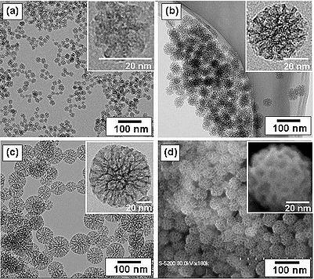

COPPER AND GOLD NANO PARTICLES

Current options for capturing carbon dioxide (CO2) emissions include [storing CO2 deep in the earth](http://www.treehugger.com/corporate-responsibility/important-why-carbon-sequestration-wont-save-us.html) or [converting CO2 into carbonate](http://www.treehugger.com/clean-technology/british-scientists-develop-another-waste-co2-conversion-technology.html), a rocky substance like the structure of ocean coral. Drawbacks of storage include fears about geological effects and mass escape of the gas. Conversion to carbonates remains inefficient.

Those two options, chemically speaking, consist of leaving CO2 unconverted for storage or adding oxygen to produce carbonate. A trickier chemical pathway consists of removing oxygen from the carbon, adding hydrogen instead -- which produces methane (CH4). The methane can be used for fuel, creating a sustainable loop of fuel to CO2 to fuel.

You know there is no such thing as a perpetual motion machine, so you can imagine that the conversion to methane requires energy. A catalyst can reduce the energy requirements -- in this case copper is known to catalyze conversion of carbon dioxide to methane with relatively little energy input. This would already have been embraced as a great solution if it were not for one problem: the copper quickly forms an oxide coating, like the patina which turns red copper roofs a beautiful (and stable) silver-green color.

The nanoparticle coating of hybrid copper and gold can be applied to the surface of electrodes. It leverages copper's excellent catalytic capacity while the gold prevents formation of oxide layers so the process can continue to operate at low energies.

To make the nanoparticles, researchers started with solutions of gold and copper nanoparticles (the red and green beakers at the back of the image above). Mixing these produces the red-brown solution at the front of the photo, from which the dark powder of hybrid gold-copper nanoparticles is extracted.

It has proven the effectiveness that one third gold in the mix for promoting the low energy reaction indicative of catalysis without film formation. Although gold is expensive, the electrode coatings can be used for long periods, contributing to a cost effective solution to the carbon dioxide greenhouse gas problem.

APPROXIMATE COST AND TIME OF DOING THE EXPERIMENT, MAKING THE CHARTS AND MODEL

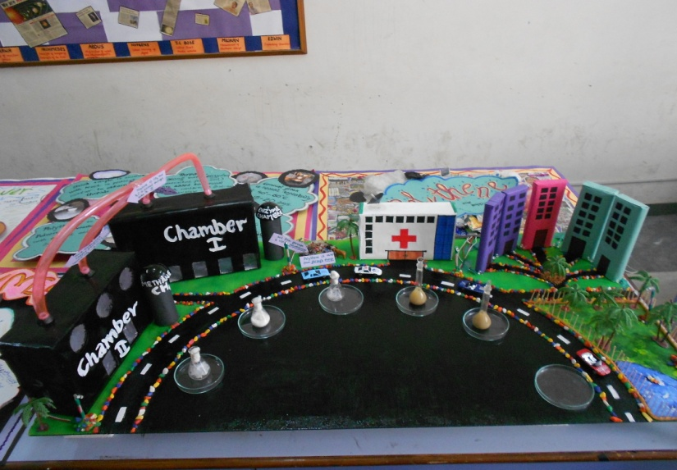Approximate cost  Rs. 1000/-  
Approximate time  3 weeks

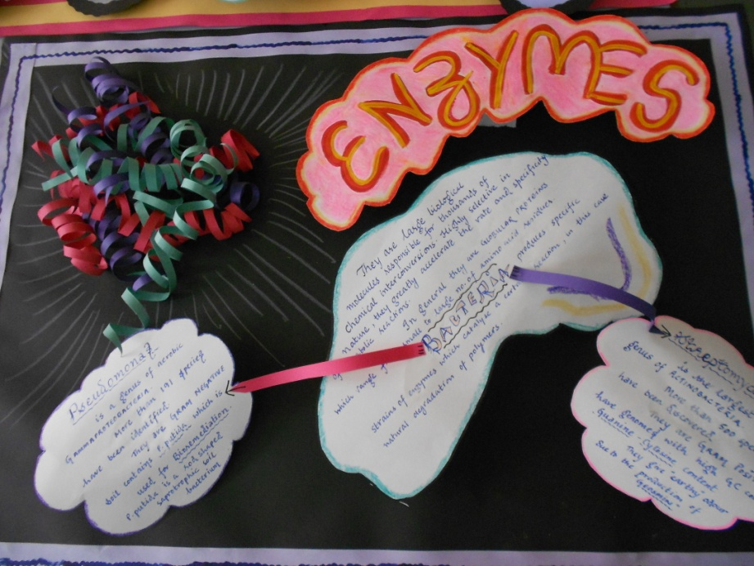

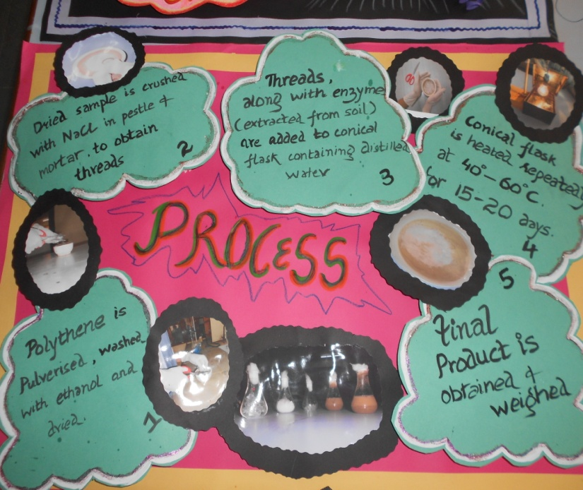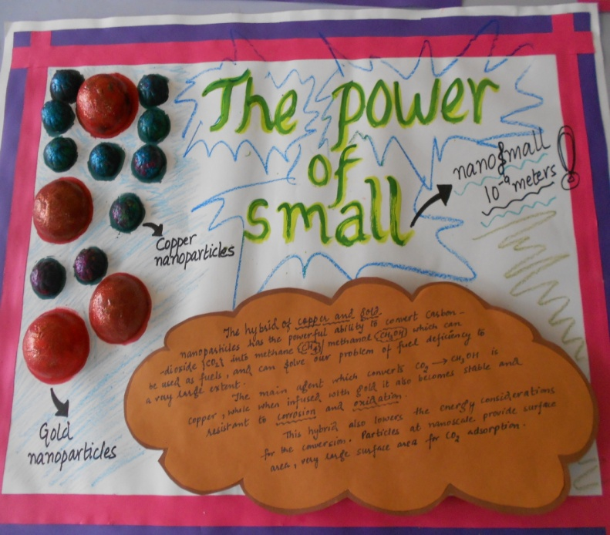

# Approximate cost of setting up a plant for polythene degradation

|  |  |  |  |
| --- | --- | --- | --- |
| Material Required | Quantity | Rate | Price (INR) |
| Land | 1-2 acres | Free* | 0 |
| Buildings | 2 | 4 crores | 40000000 |
| Nutrient Broth | 100 pcs | $1000/100 pcs | 55000 |
| Incubator (CO2 and O2) | 50 | $1100/pc | 3025000 |
| Solar Panels (2m*2m) | 500 | $200/pc | 5500000 |
| Batteries | 100 | $195/pc | 1072500 |
| Copper nanoparticles | 3 ton | $800/ton | 132000 |
| Gold nanoparticles | 1 ton | $400/gram | 40000000 |
| Miscellaneous expenses | 0 | 0 | 2500000000 |
| **Grand Total** |  |  | ***258,97,84,500\*\**** |

Free* - as the setup would be done by the government. Therefore the land would be of the government only.

The total cost would be nearly *280 crores*.

*\*\**This estimate is provisionally made so the cost of making the plant may be more than 280 crores or less than 280 crores.

**The advantage of setting of this plant would be:**

1. **We would be making our world free from polythene.**
2. **And from this plant methane would be generated which will act as an efficient and affordable fuel.**

# CONCLUSION

# The present research focuses on the biodegradation of LDPE by Brevibacillus, Pseudomonas, and Rhodococcus spp. by pure culture shake-flask incubation method. The percentage of biodegradation was evaluated by comparing the initial and final dry weights of polyethylene before and after incubation. The hypothesis of the study was microorganisms will utilize LDPE as the sole source of carbon and energy when the rest of the nutrients in the broth are limited.

# Although there have been numerous investigations in degrading LDPE, yet the fate of these organic polymers in the environment and the time required for their complete mineralization to carbon dioxide needs to be fully understood. There is a growing interest in examining the activity of a consortium of microorganisms to expedite the biodegradation rate.

# The plastic which takes more than 1000 years to degrade can now be degraded within few months with the POWER Of SCIENCE.